
SYSTEM PLANNING

STARTING DATE : 5 / 12 /2025

DESCRIPTION | QTY | TOTAL
Web Server (CPANEL) | 1 | RM 220
Domain name | 1 | RM 70
MYQL DATABASE | 1 | RM 90
CLOUDFLARE DNS | 1 | RM 75
TAILWIND COMPONENTS | 1 | RM 100

Remarks / Payment Instructions

SUBTOTAL | RM 555.00
DISCOUNT | RM 00.00
AFTER DISCOUNT | RM 555.00
TAX RATE | 0.00%
TOTAL TAX | 0.00
UPTIME PAYMENT: | RM 50 / month

Payment Total : RM 555

NAMA APLIKASI:
JENIS APLIKASI: INVENTORY
KAEDAH HOSTING: CPANEL HOSTING

MODUL PEMBANGUNANAN
- INVENTORY
- ITEM

SKOP
- KEMASKINI ITEM
- KEMASKINI INVENTORI
- LIHAT DATA INVENTORI

ERD
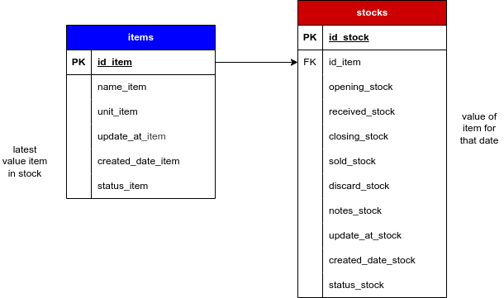

FLOWCHART

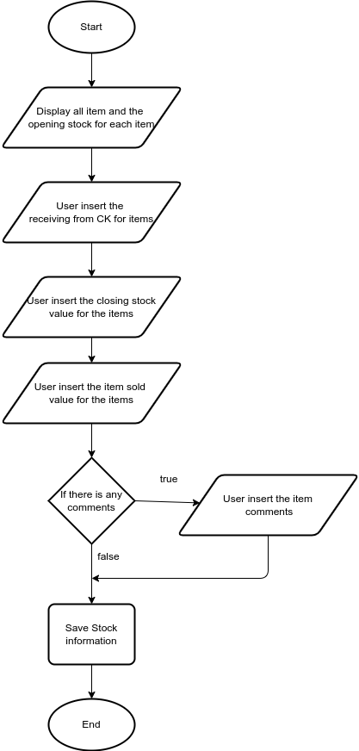
PILIHAN INTEGRASI

Penggunaan Sementara / Prototaip

PERKARA HAK MILIK SENDIRI BERSAMA |  |  | SEMENTARA
Pendaftaran MYIPO (hak  cIpta) | – Nama sendiri | – Nama bersama | - Tiada
Pendaftaran inovasi | / | / | X
Kos penyelengaraan | RM 30 / bulan | RM 10 / bulan | RM 0
Kos penggunaan | RM 50 / bulan | RM 30 / bulan | RM 30
Kos pembangunan | 100% | 60% | 50%
Kos menaiktaraf | RM 100 | Ikut kesesuaian | RM 0

Penggunaan komersial

PERKARA Heavy Use Minimal Use
Backup database | / | X
Kos penyelengaraan | RM 30 / bulan | RM 20 / bulan
Kos penggunaan | RM 70 / bulan | RM 50 / bulan
Kos menaiktaraf | Ikut kesesuaian | Bawah RM 100

PENUKARAN PENULISAN

3.2.1 Prototyping Model
In developing a digital system, a structured methodology is essential to ensure the system meets its requirements and functions effectively as a framework. This study employs Agile methodology, an iterative approach within the broader context of the System Development Life Cycle (SDLC). Agile provides researchers and users with a flexible framework to understand and execute system development, ensuring the final product aligns closely with user needs through continuous feedback and adaptation.
The Agile approach is inherently iterative and incremental, as the system requires ongoing refinement based on user input. This methodology is particularly advantageous when users have difficulty articulating detailed specifications for inputs, processes, and outputs, which can create uncertainty for developers regarding optimal algorithms, system operations, and human-machine interaction (Nur, Bahar, Muhammad Ghifari Arfananda, & Helina Apriyani, 2021).
Key Agile practices that address these challenges include:
- Evolutionary Development through Sprints: The system is built incrementally in short, time-boxed cycles called sprints. Functionality is continuously developed and refined to meet evolving system needs.
- User Story Definition and Backlog Refinement: Developers work closely with users to define requirements as "user stories" when clear specifications are lacking. The product backlog is continuously refined to capture and prioritize system functions and procedures.
In the hospitality and food & beverage industry, Agile is highly effective. For instance, when developing a digital inventory system for a restaurant, the first sprint might deliver a basic feature for logging raw materials. After a review with kitchen staff, the subsequent sprint could incorporate new user stories for automatic low-stock alerts, followed by another sprint integrating supplier information. This iterative cycle of planning, development, and review ensures the final system is practical, user-oriented, and perfectly aligned with actual operational workflows.

